







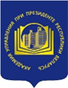



**Report on the Belarusian National Library Awareness Day**

**(Minsk, May 19-20, 2017)**

On May 19-20, 2017, the National Library Awareness Day was held in Minsk under the auspices of the Erasmus+ LNSS Project. The aim of the event was to demonstrate the potential of libraries for the development of [life-long learning](http://context.reverso.net/%D0%BF%D0%B5%D1%80%D0%B5%D0%B2%D0%BE%D0%B4/%D0%B0%D0%BD%D0%B3%D0%BB%D0%B8%D0%B9%D1%81%D0%BA%D0%B8%D0%B9-%D1%80%D1%83%D1%81%D1%81%D0%BA%D0%B8%D0%B9/life-long+learning), as well as for the creation of a positive image of libraries in society involving the participation of primary, secondary, and higher educational institutions on an agreed day. This Day actually took place over a two day period so it can be justifiably referred to as National Awareness Days!

This included active student participation of Universities, National and Public Libraries, Associate Partners, Student Unions, Teacher Unions with the support of the Education Ministries and NGO’s.

The 1st Library Awareness Day in Belarus was organized in the framework of the 3rd City Festival on May 19-20, 2017 "The City and Books", which is one of the largest book events in our country. The most interesting book projects, well-known authors, publishers, librarians and readers had already traditionally gathered at this festival. This year the campus and park located on the main avenue of Minsk (Nezavisimosti Ave. 65) at the Belarusian National Technical University (BNTU) was chosen as the venue for the festival due to its size, facilities and accessability.

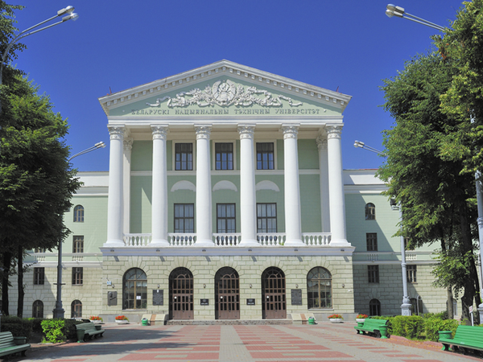

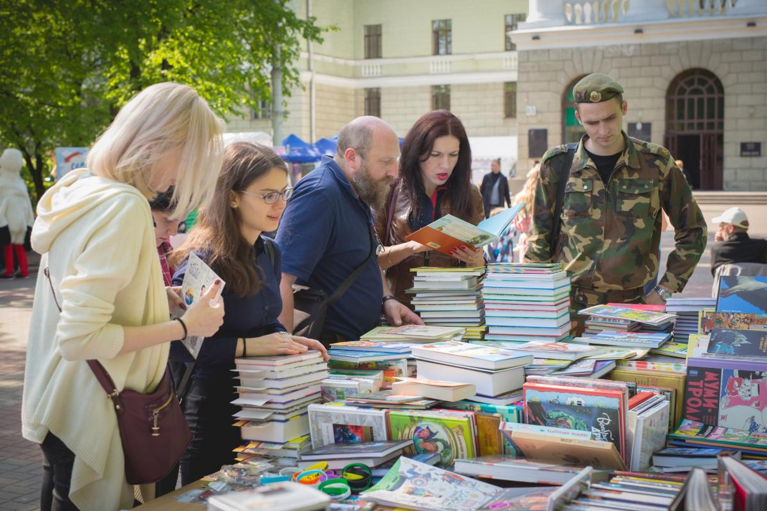

In the framework of the preparation for the festival, an organizing committee was set up by the partners.

The Director of the BSU Fundamental Library V. Kulazhenko who officially opened the event and additionally gave an interview about the event and its objectives for the 2nd Channel of the National Television and for the Channel "Culture" of the National Radio[1].

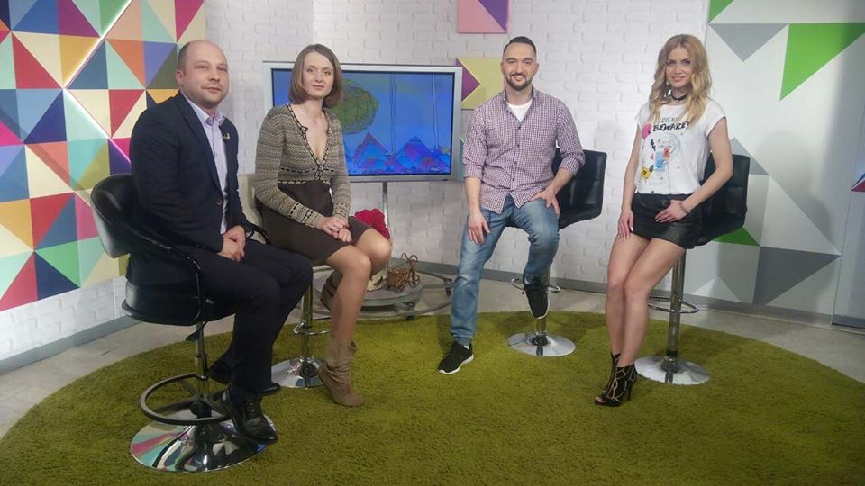

BSU Press-service office supported the event. The office disseminated information, sent out press releases. News about the event was posted on the main site of the university:

[https://bsu.by/main.aspx?guid=235071&detail=820953](Https://bsu.by/main.aspx?guid=235071&detail=820953)

Besides that, the announcement of the event was posted on various news Internet portals and in hard copy newspapers, among them:

*- «III Фестываль «Горадікнігі» пройдзе 19 і 20 мая ў Мінску»(Belarusian)*:

<http://zviazda.by/be/news/20170517/1495015844-iii-festyval-gorad-i-knigi-proydze-19-i-20-maya-u-minsku>

*- “Фестиваль «Город и книги» пройдет в новом формате в ма*е”*(Russian)*:

<http://www.aif.by/timefree/afisha/festival_gorod_i_knigi_proydet_v_novom_formate_v_mae>

*- “Уличный фестиваль книги пройдет в Минске 19-20 мая”(Russian)*:

<http://www.belta.by/regions/view/ulichnyj-festival-knigi-projdet-v-minske-19-20-maja-247991-2017/>

*- “В Минске уличный фестиваль книг проведут прямо на скамейках” (Russian)*:

<http://citydog.by/post/zaden-gorod-i-knigi/>

*- Программа фестиваля "Город и Книги (на скамейках)" (Russian)*:

<http://www.bla.by/new/item/553-программа-фестиваля-город-и-книги-на-скамейках.html>

The NA Day was supported actively in social networks. The event was created on Facebook and also in the most popular Russian-language network –“Vkontakte”. Information was distributed in library accounts and on personal pages.

Universities organized the whole festival area. Pavilions for all events and book projects were installed. For the event's branding, the banners of the LNSS project and the National Awareness Day were made, T-shirts for participants and volunteers with the logo of the LNSS project, cups for prizes to participants in the competitions with the logo of the LNSS were produced. For the exhibition, visual materials and brochures with information about libraries, library services and resources were printed.

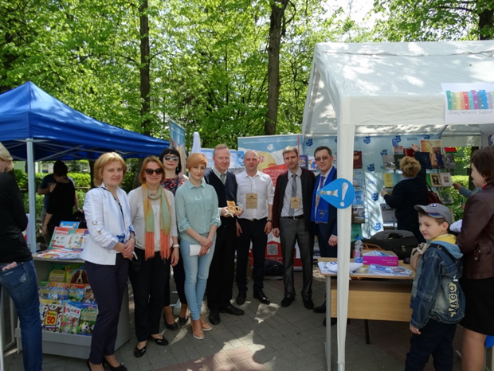

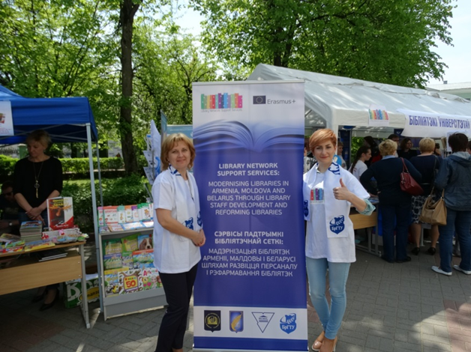

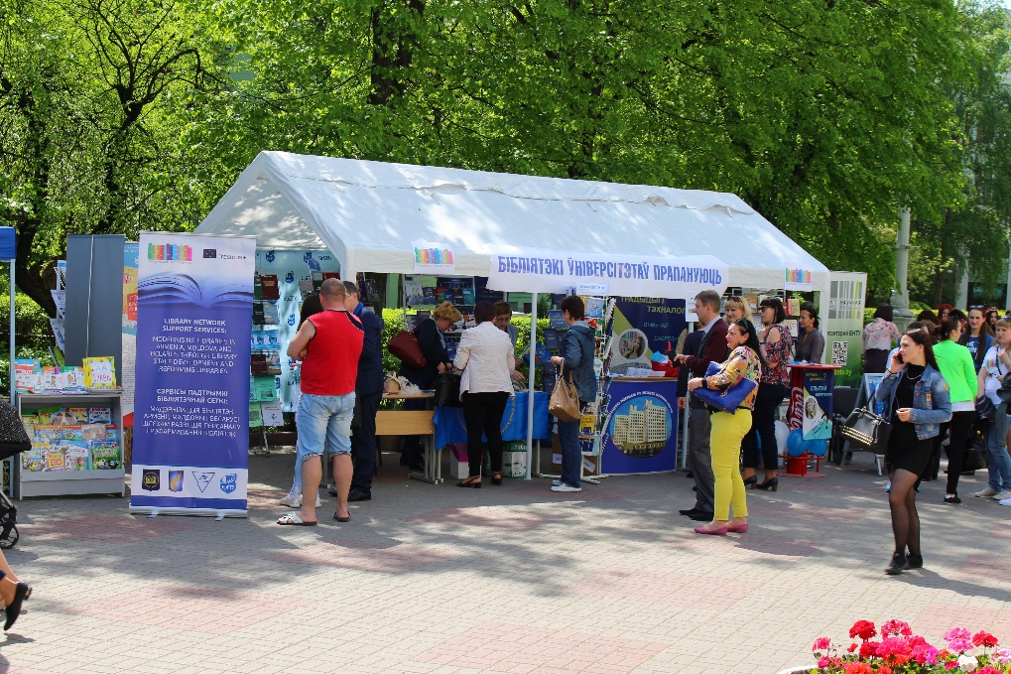

At the organized "Expert meeting place", which brought together experts in the library management from different countries, the heads of the working groups of LNSS Project universities from Belarus V. Kulazhenko (BSU), N. Hrynko (YKSUG), A. Anokhin (APA), N. Chetyrbock (BrSTU), held a presentation of the LNSS project. The EU representative from the Pyramid Group spoke about the current direction and developments of the libraries activities.

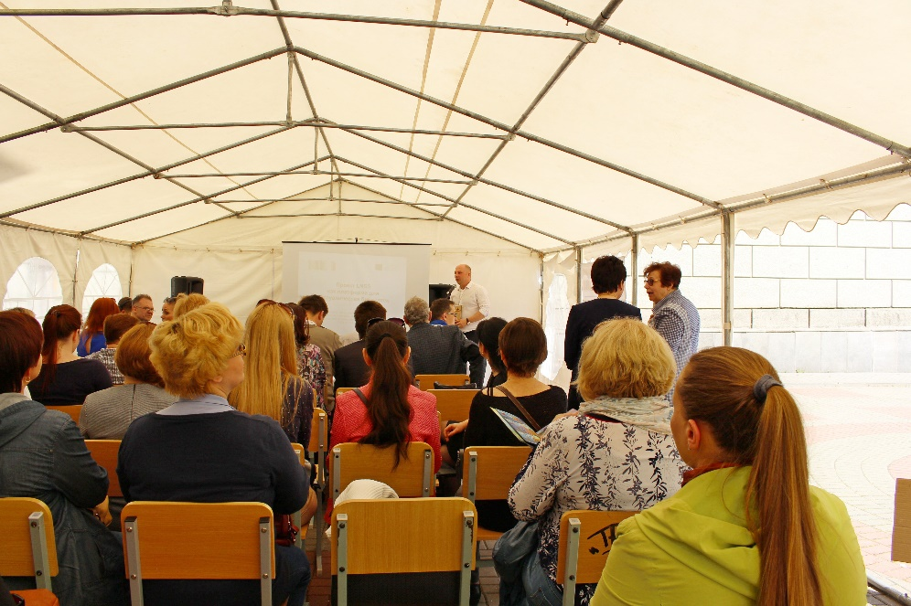

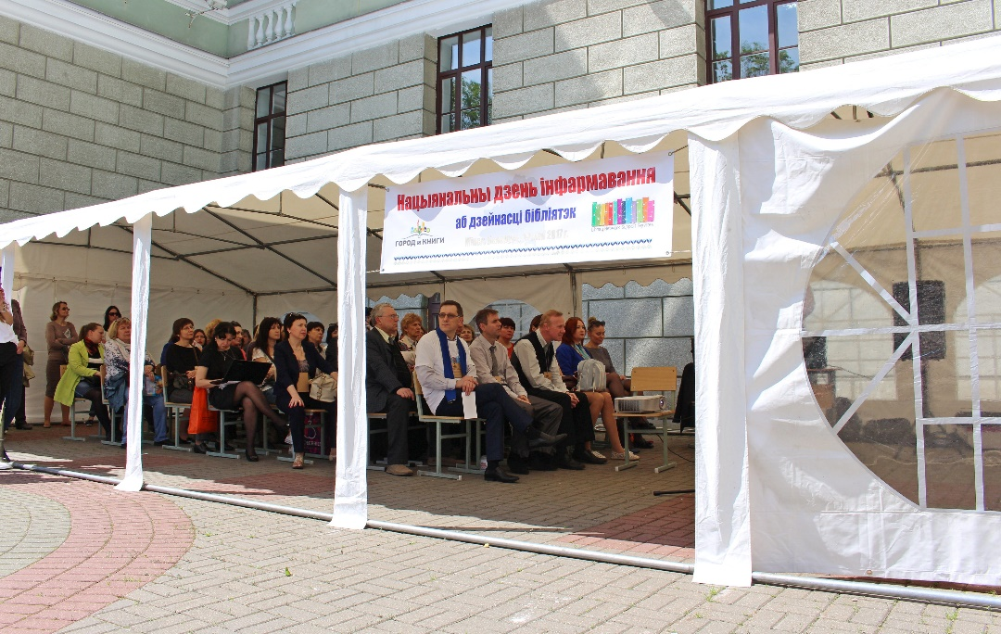

At the same time, on the discussion platform, substantive reports were made on network library projects organized in German (Goethe-Institut) and Belarus (Belarusian Library Association), as well as on the corporate interaction of librarians in Ukraine (Ukrainian Library Association).

In addition, a temporary pavilion was organized at the exhibition site, where the consulting service "Ask a librarian" was functioning. Project presentations were given including presentations by students' and staff and other stakeholders. On the main campus there were book exhibitions, various youth projects, childrens primary school events. On both evenings a concert program of YKSUG students was organized.

In total, more than 5000 thousand persons visited the festival consisting of all age groups and all walks of life over the two day period.

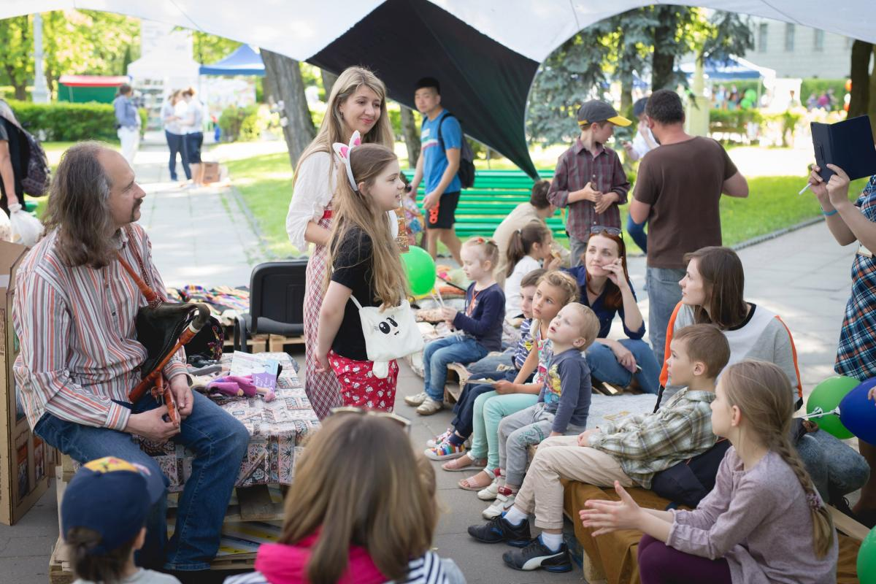

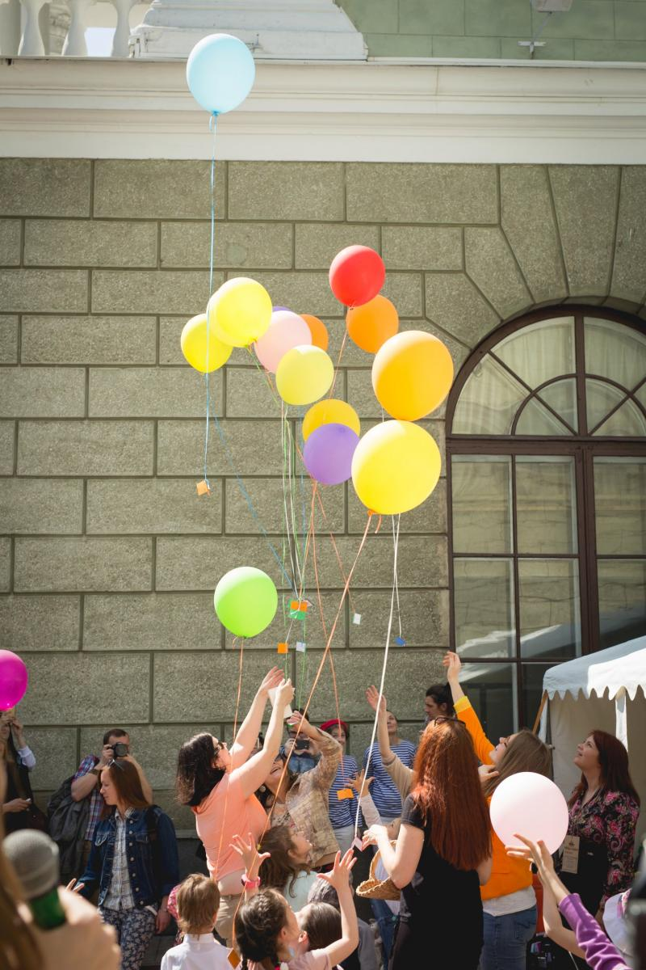

A lot of media reports were made about the event in media resources.The reports about the event were shown on TV and posted on various Internet portals. Also reports on activities with photos were posted on the websites of Universities, as well as participants and organizers of the event, among which were:

Website of the BSU Fundamental Library (Russian):

<http://library.bsu.by/index.php/about-library/proektnaya-deyatelnost/otchety/700-natsionalnyj-den-informirovaniya>

The site of the BrSTU (Russian):

<http://www.bstu.by/en/universitet/biblioteka/proekt-lnss>

The site of the Scientific Library of the YKSUG (Belarusian):

<http://www.lib.grsu.by/content/Natsiyanalny-dzen-infarmavannya-abdzeynatsi-bibliyatak>

The site of the YKSUG (Belarusian):

<https://www.grsu.by/ru/component/k2/item/21293-v-minske-23-maya-sostoyalsya-natsionalnyj-final-xxvi-mezhdunarodnogo-mezhvuzovskogo-konkursa-gratsii-i-artisticheskogo-masterstva-koroleva-vesna-2017-za-pravo-stat-luchshej-borolis-15-konkursantok-studentki-uchrezhdenij-vysshego-obrazovaniya-belarusi-sr.html>

On the APA website (Russian):

<http://www.pac.by/ru/biblioteka/library-news/festival-gorod-i-knigi_i_0000006700.html>

On the site with the co-organizer - BNTU (Russian):

<http://library.bntu.by/v-minske-v-tretiy-raz-proshyol-festival-gorod-i-knigi>

On the site of the partner of the event - the Ukrainian Library Association (Ukrainian):

[https://ula.org.ua/news/3731-minsk-knyzhkovyi-i-bibliotechnyi-dilymosia-vrazhenniamy](Https://ula.org.ua/news/3731-minsk-knyzhkovyi-i-bibliotechnyi-dilymosia-vrazhenniamy)

Also photo reports were posted on the libraries pages in social networks, among which:

LNSS Belarus Group:

[https://www.facebook.com/groups/176860272814146/](Https://www.facebook.com/groups/176860272814146/)

FB BSU Group:

[https://www.facebook.com/flbsu](Https://www.facebook.com/flbsu)

YKSUG Group:

[https://www.facebook.com/profile.php?id=100010827069202&sk=photos&collection_token=100010827069202%3A2305272732%3A69&set=a.421869128183986.1073741830.100010827069202&type=3&pnref=story](Https://www.facebook.com/profile.php?id=100010827069202&sk=photos&collection_token=100010827069202%3A2305272732%3A69&set=a.421869128183986.1073741830.100010827069202&type=3&pnref=story)

<https://vk.com/slibgrodno?w=wall-122962928_13>

The BNTU Group:

[https://www.facebook.com/bntulibrary](Https://www.facebook.com/bntulibrary)

A photo report was placed in the “Digital Photo Archive of BSU”: [http://earchives.bsu.by/handle/link/3140](Http://earchives.bsu.by/handle/link/3140)

In general, the goals were achieved in the framework of the event. At the expert event, the exhibition site, the residents and visitors of the city were informed about libraries and their possibilities. It was possible to create a noticeable information effect on promoting the stated objectives and also an interest in libraries in Belarus.

The report on the event was sent to the National Erasmus+ Office.

Belarus LNSS Library Action Group

Minsk,

19.06.2017

1. Photo in the studio of the TV Channel "Belarus-2": <Https://www.facebook.com/photo.php?fbid=1545029282187992&set=a.1050263924997866.1073741832.100000428068795&type=3&theater>