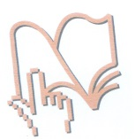 **JU Kantonalna i univerzitetska biblioteka Bihać PI Cantonal and University Library Bihac**

**Trg slobode 8, 77 000 Bihać, BiH Trg slobode 8, 77 000 Bihac, BiH**

**Tel./fax +387 (0)37 222 025 Tel./fax +387 (0)37 222 025**

**e-mail: kbbi.bihac@bih.net.ba e-mail: kbbi.bihac@bih.net.ba**

Bihać, 28. septembra 2017. godine

**Subject: Information on NLAD activities**

On 8 September 2017 Cantonal and university library in Bihac organized series of events to mark National Library Awareness Day, which also included other educational institutions in Una-Sana Canton and BiH. The list of organized activities is as follows:

**Cantonal and university library in Bihac**

Cantonal and university library in Bihac organized two events to mark National Library Awareness Day 2017. Librarian of the Bookmobile service held presentation of library, its services and resources in the Elementary school Gata Ilidža Vrsta, located in the suburbs of Bihac. After the presentation, a workshop was organized for students in grades 1-5.

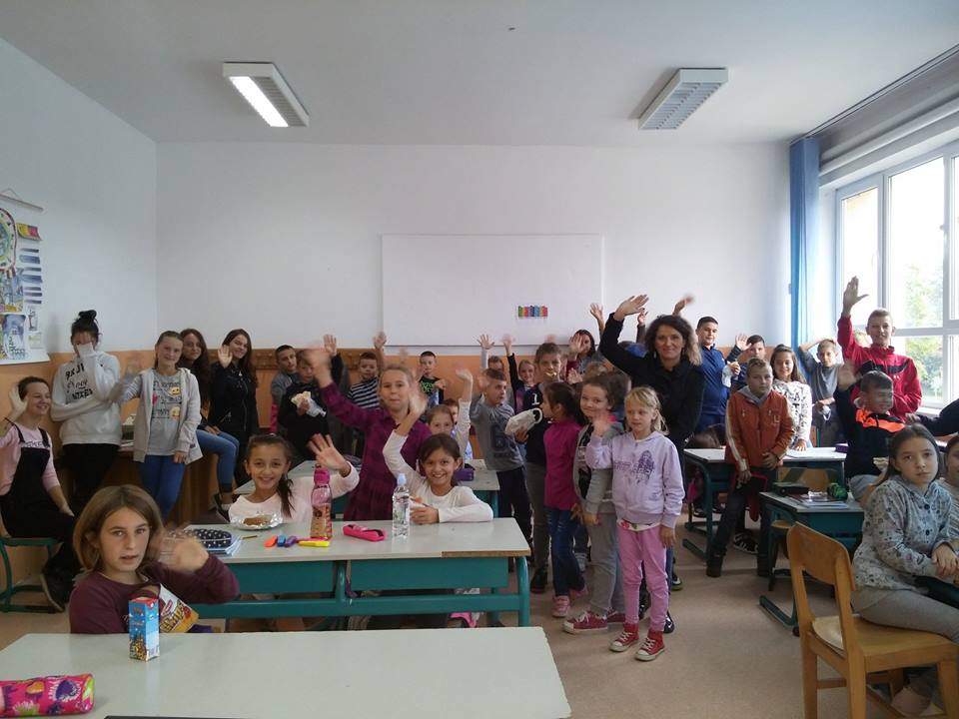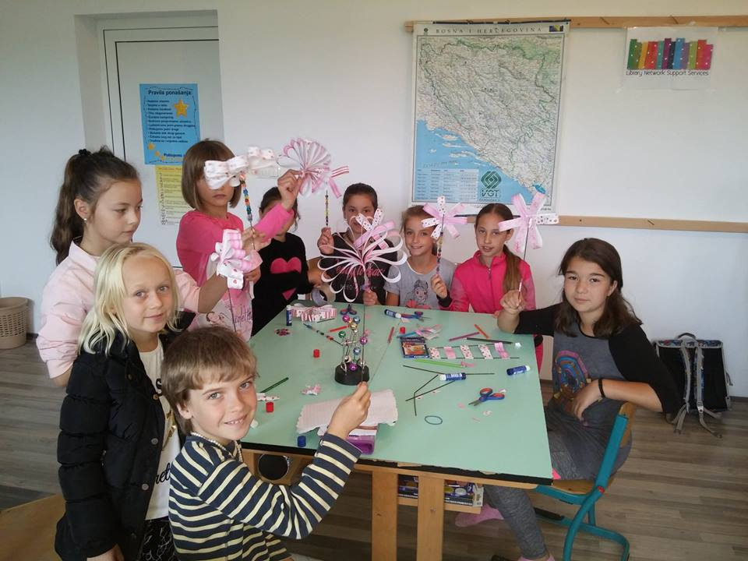

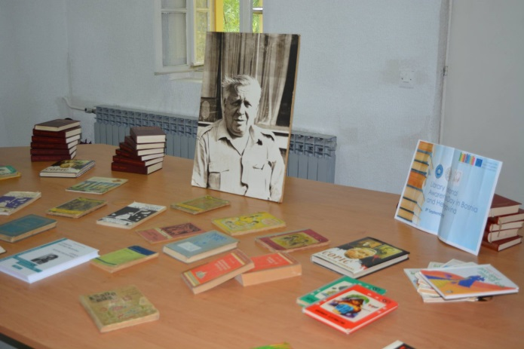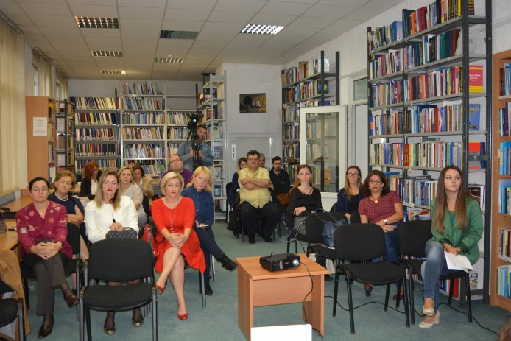Library organized exhibition and international symposium dedicated to one of the most famous writers in BiH Branko Ćopić, *‘’Ćopićeva poetika zavičaja’’*. The Symposium gathered some of the most prominent experts in Bosnian language and literature.

**High school Gimnazija in Cazin**

Librarians organized visit to the library, followed by the presentation that included information on the definition and activities of library, types and classification of libraries, library resources and reading room.

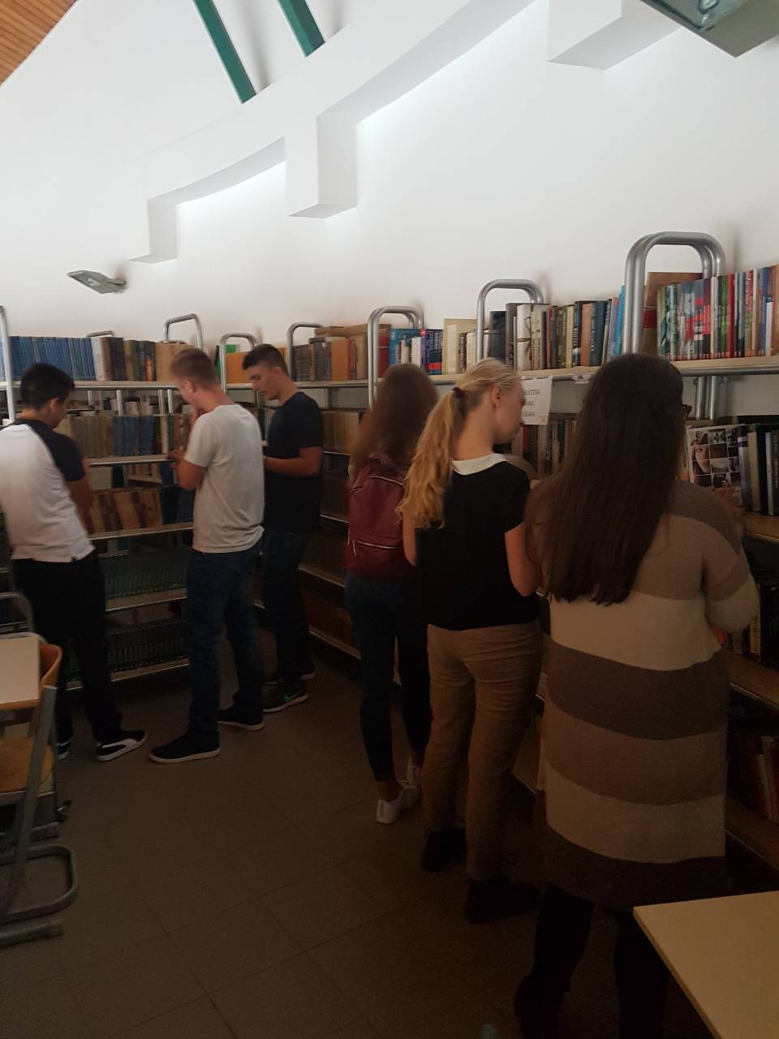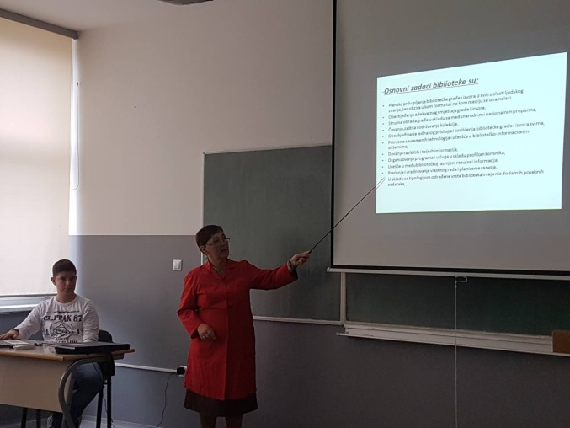

**Elementary school ''Prva sanska skola'' in Sanski Most**

* First and second grade students visited school library, where librarian gave brief presentation about the library and its activities. Each student had an opportunity to talk about his or her favorite book and book characters. They were then divided into groups and created their own stories.
* Third and fourth grade students visited City library of Sanski Most and learned about the library and its resources.
* 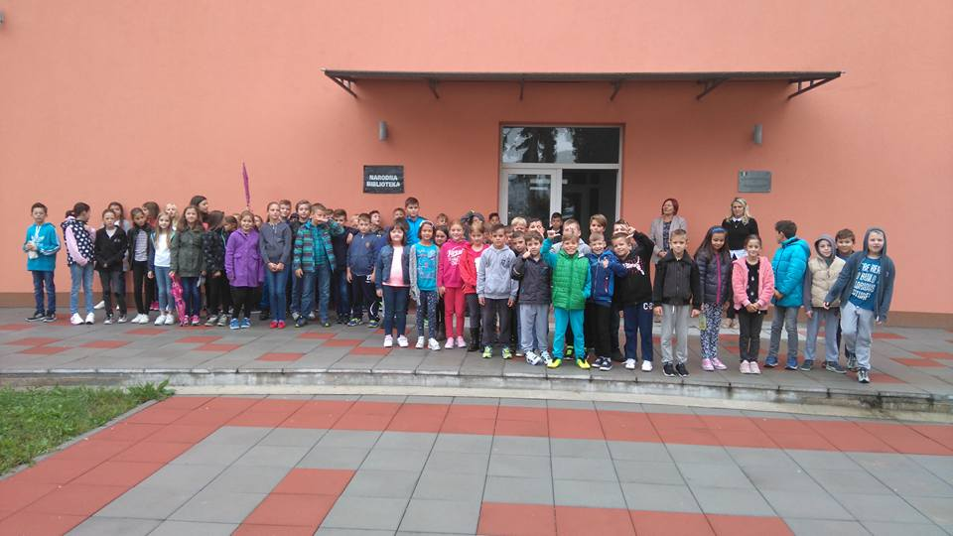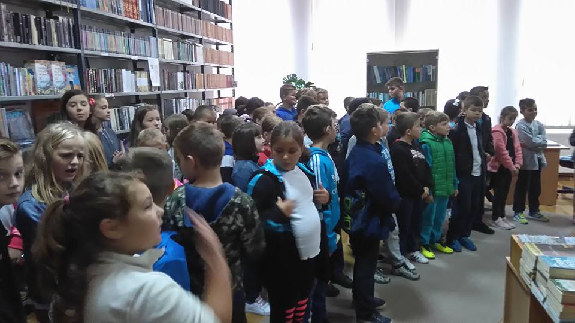Teachers of Bosnian and English language held workshops/presentations in their respective classes, on the topic of books and libraries.

**Elementary school ''Prekounje'' in Bihać**

Students of third and fourth grade visited school library, where librarian gave brief presentation about the library and its activities. After presentation, English language teachers organized workshop and learned songs and words related to libraries. Students also created their own books.

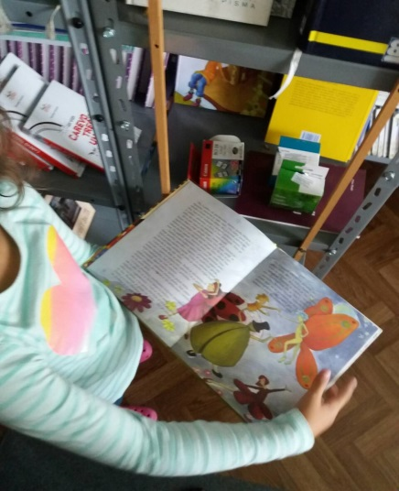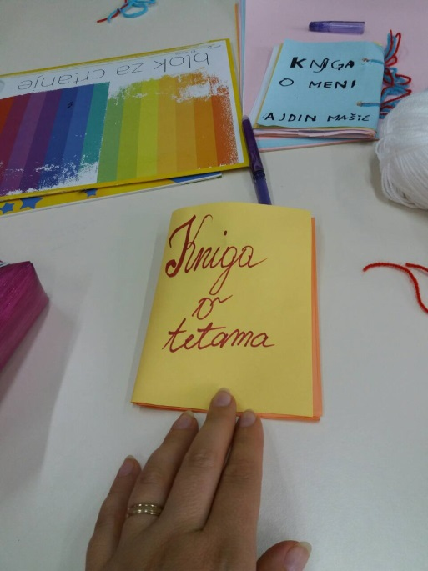

**Elementary school ''5. oktobar'' in Sanski Most**

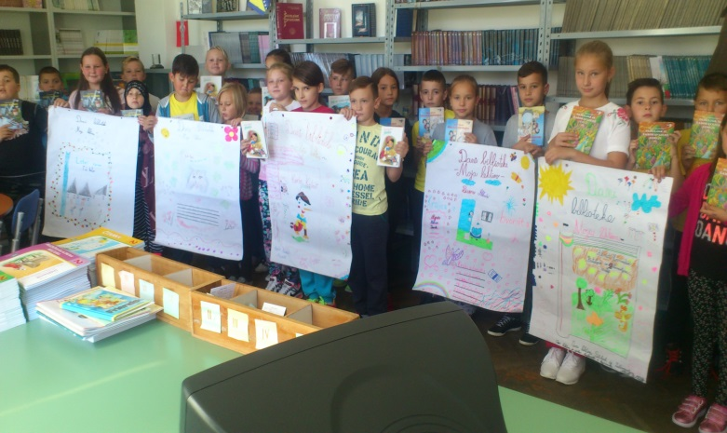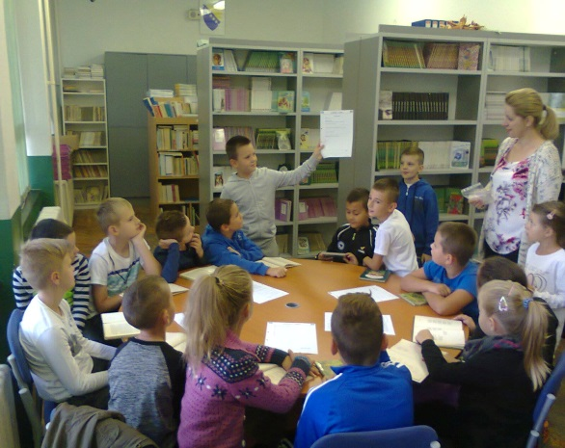Students visited the school library and learned about their resources and activities. Librarians also organized educational activities and discussed the importance of libraries in their education and everyday life with students.

**High school ‘’1. srednja škola’’ in Velika Kladuša**

Students – members of literary and journalist clubs organized presentation and workshop on the topic of literary work of famous Bosnian poet Aleksa Šantić.

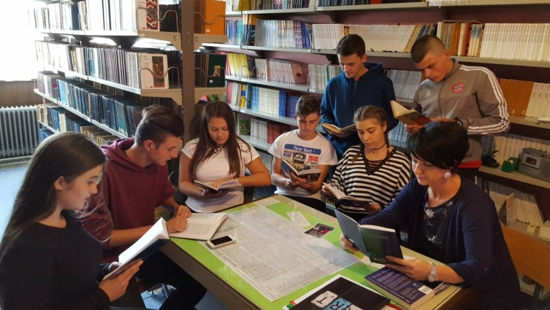

**American Corners in Bosnia and Herzegovina**

Four American Corners in BiH participated in the NLAD activities – Bihac, Doboj, Mostar and Zenica. They all organized the same activities: exhibition and presentation of EducationUSA materials.

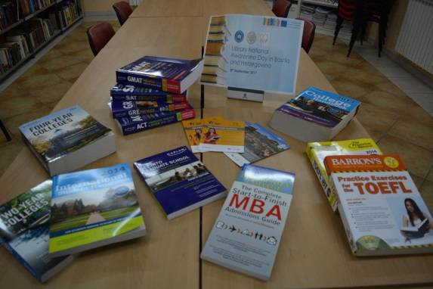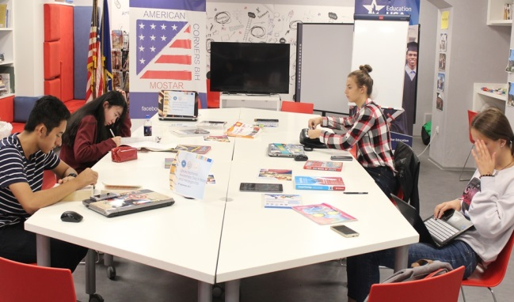

Acting Director

Mirela Midžić