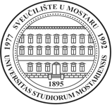

Pilot1. LNSS project, MODUL No.3:

**ESSENTIAL MANAGEMENT AND TRANSFERABLE SKILLS**

**FOR LIBRARIANS AND LIBRARY STAFF**

Faculty of Philosophy, Matice hrvatske b.b., 88000 Mostar

**P R O G R A M**

Tuesday, 19 December 2017

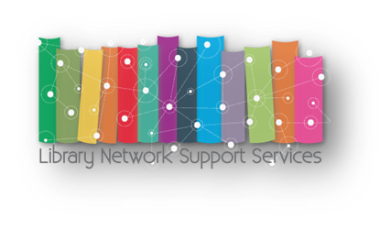

|  |  |
| --- | --- |
| 12:00 – 12.30 | **Registration of participants** |
| 12:30 – 12:45 | **Welcome speech**  **SanjaBijakšić**, PhD, Vice-Rector for International Relations |
|  |  |
| 12:45 – 13:00 | |  | | --- | |  | | **Introductory speech**  **Angela Repanovici i Manolis Koukourakis,** EU partners | |
| 13:00 – 13:45 | |  | | --- | | **Modul No.3 – Essential management and transferable skills for**  **librarians and library staff**  Presentation for librarians and University staff | | **Štefica Dodig**  **Josip Šimić** | |
| 13:45 – 14:00 | **Coffee break** |
| 14:00 – 14:30 | **Evaluation / Discussion** |
|  |  |
|  |  |

[/LNSS_WB](https://www.twitter.com/LNSS_WB)

[[facebook logo](https://www.facebook.com/LNSS.WB) /LNSS.WB](https://www.facebook.com/LNSS.WB)

<http://lnss-projects.eu/bal>