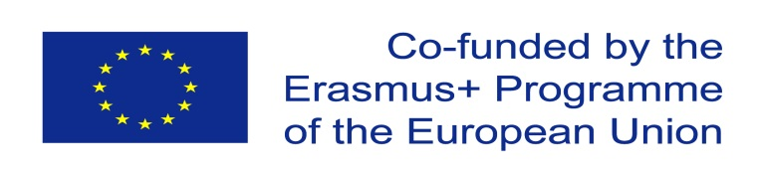 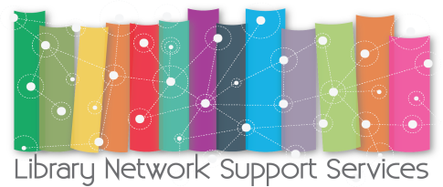

**LIBRARY NETWORK SUPPORT SERVICES (LNSS): Modernizing Libraries in Western Balkan Countries through Staff development and reforming Library Services**

**Sarajevo 2017**

On 8 september 2017 Sarajevo University initiated a round table titled “Upravljanjekvalitetomrada u visokoskolskimbibliotekama” - **Managing the quality of work in high school libraries**, on the Library National Awareness Day in Bosnia Hertegovina within the framework of the ERASMUS+ LNSS project.

The meeting brought together librarians, academicians and students from different universities the members of BIH Libraries, representatives of the LNSS project partner universities from abroad (Dr. Claudiu Coman from Transylvania University of Brasov, Romania, mr. sc. Jerald Cavanagh, project leader, Limerick Institute of Technology, mr.sc. Padraig Kirby, project coordinator, Limerick Institute of Technology).

Objectives of the Round Table was:

* Presentation of the Library Network Support Services project staff, librarians, students, educational authorities, representatives non-governmental sector and the media
* Presentation of the representation of mission representation and vision of the library on the web sites of high-school institutions at UNSA
* Analyzing the results of the self - evaluation of library competences and suggesting new ones with a view to improving customer service
* Pointing to the importance of implementing information literacy in the rise the quality of high school library services

Round table was opened by Prof. Dr. Maida Oohodar Husié, Vice President for UNSA Quality  
Mr. Suad Muhibié, National ERASMUS + Officer in B & H Doc. Dr. Lejla Hajdarpasié, Library Network coordinator Support Services for UNSA.

Dr. Sc. Babe Esrefa Rasidovié, a member of Library Network Support Services Team Raising the quality of the services of high school libraries through the implementation of information literacy programs, sc. Jerald Cavanagh, project leader, Limerick Institute of Technology, mr. sc. Padraig Kirby, project coordinator, Limerick Institute of Technology had a presentation about Library Network Support Services: librariesin Western Balkan countries through staffdevelopment and reforming library services modernize the library and improve the level the competence and abilities of he library staff in High School Institutes.

Through the development of innovative libraries as well support for education and the all-embracing  
learning to structure the library development strategy staff focused on improving standard and quality of work libraries in to the countries of the Western Balkans, and to do so improve the quality of library services and higher education in general, and theirs the importance of labor market and society

Improve management and availability library in the countries of the Western Balkans through strategic planning and policy development establish and maintain a library network in  
the countries of the Western Balkans with the goal dissemination, sustainability and exploitation  
project results in the future, on national and regional level Library Network Support Services: Overview of realized and planned activities Mr. sc. Irena Pejic, a member of Library Network Support Services Team Analysis of mission representation and vision of the library on the websites of the High-Level Institutions at the University of Sarajevo Prof. Dr. Senada Dizdar, a member of Library Network Support Services Team Panel Discussion and Conclusion Sasa Madacki, moderator and clan Library Network Support Services team.

The round-table discussion was a success due to the fruitful discussion on key issues with regard to using copyrighted materials. The core library exceptions such as reproduction of works for private, scientific-research and educational purposes, digitalisation, interlibrary loan and document delivery, format changing for disabled people, preservation and translation of materials, etc. were discussed.

The organisators had 47 institutions that have their activities, and I visit two of them after the round table and before the central activity Walk for libraries with LejlaHajdarpasic.

Knowledge sharing session in National Library of BIH on the Library National Awareness Day

On 8 september 2017 experience exchange Session was organized in National Library of BIH on the Library National Awareness Day within the framework of the ERASMUS+ LNSS project. It was a Knowledge sharing session: librarians who participated in piloting training for Information Literacy and Research skills shared their knowledge with National Library staff members.

**SWOT** ANALYSIS NAD BIH –BOSNIA AND HERZEGOVINA LNSS PROJECT

Primary factors

**Weakness**

* **Low financial resources**
* **Reliability and trust in power of library**
* **Not so many key staff**
* **No financial support**
* **Problems with materials translation in english**

**Strengths**

* **Big number of events**
* **Universities libraries were involved in international projects, they have high experience**
* **Experience, knowledge of librarians, librarians, they are very well trained**
* **Geographical advantage, location in Sarajevo**
* **Top management support libraries**
* **Competence, capabilities in organizing events**
* **Quality, reputation of institutions**

**W**

**S**

**Opportunities**

* **Strategic alliances, partnerships between institutions, very good collaboration**
* **Awarness of library importance between students and other participants**
* **Awarness of power of library in society**
* **Increasing users needs of reading**

**Threats**

* **More sponsorship would be more positive..**
* **Strong competiotion of IT technology**
* **Absence of political factors of decisions**

**T**

**O**

**CONCLUSION**

The event had an overall positive effect. The main goals were realised namely:

1. Popularization and dissemination of activities of the project – LNSS
2. Location was very good, impact of event was maximised
3. They were very interested about importance and the role of library and digitalisation in information society.
4. We appreciate that event touch the objective of the project and dissemination was useful for the audience.

Overall the National Awareness Day in Sarajevo was a good start for the future NAD in BIH.

10 September, 2017

Prof.dr. Claudiu Coman, UTBV

Anexa:

